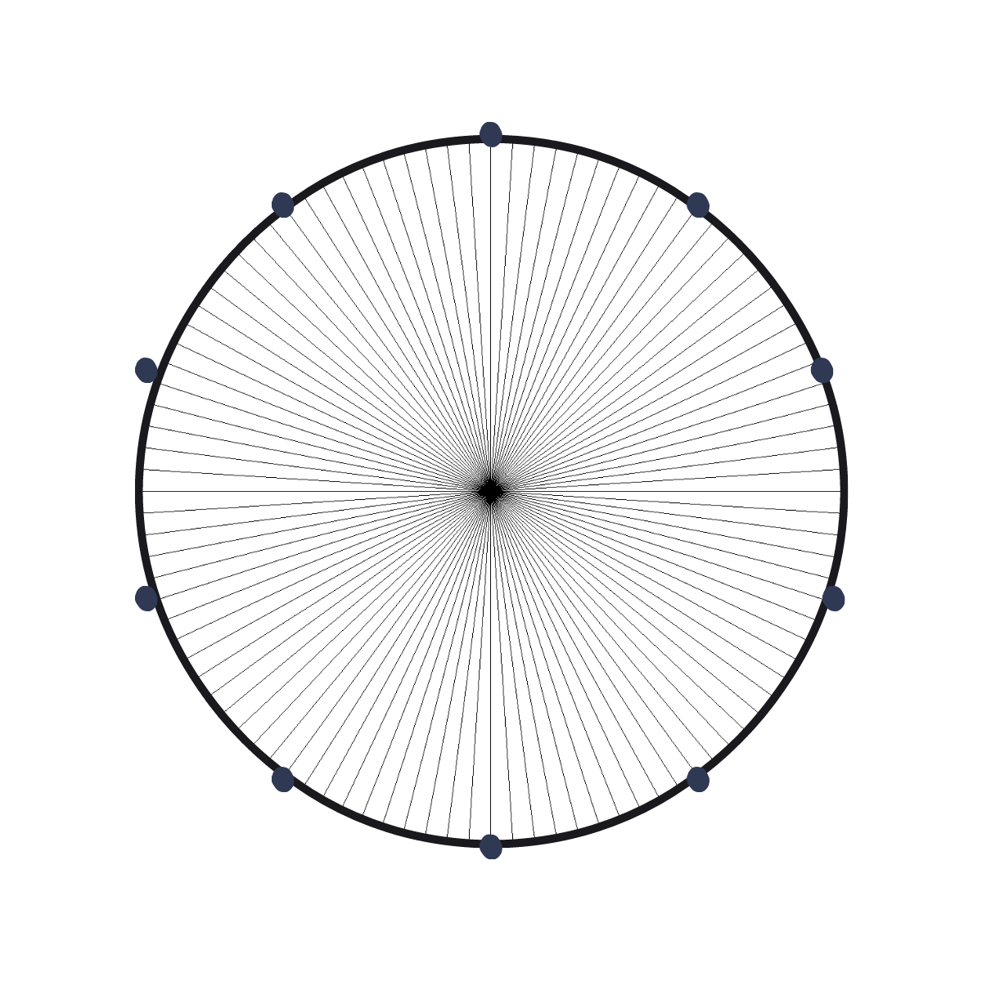
CONCEPTUAL MATH LEVEL II – FRACTIONS, DECIMALS AND PERCENTS

BASE TEN CIRCLE WITH FRACTION LINES – TENTHS
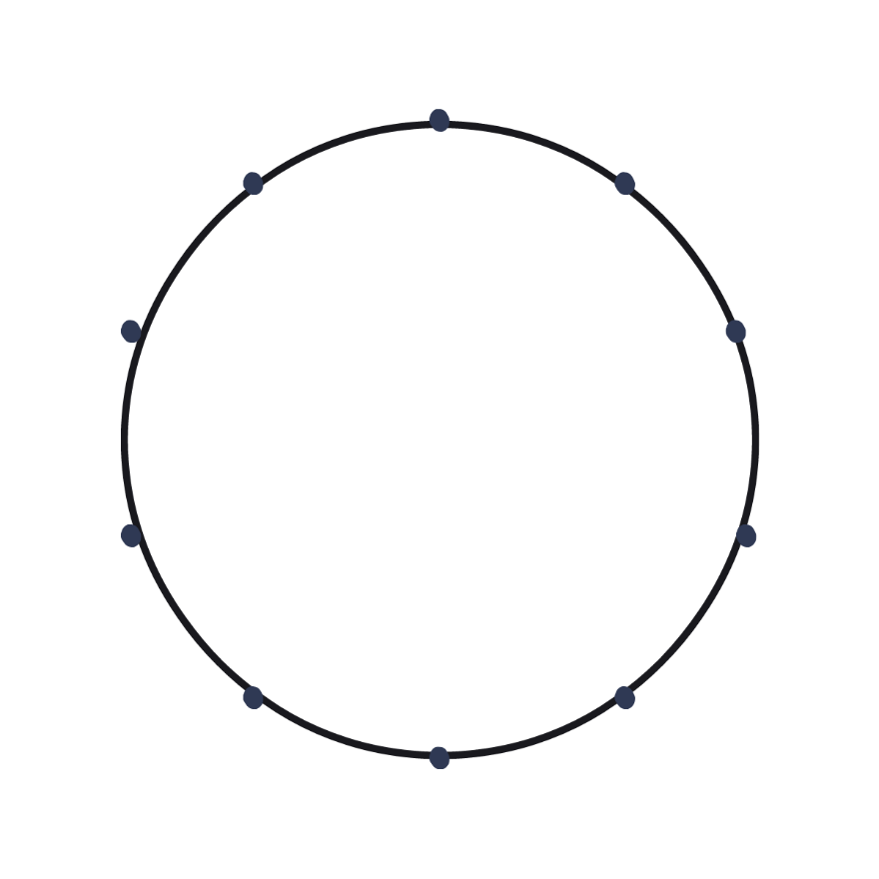

Tenths with Fraction and Decimals

Decimals and Fractions
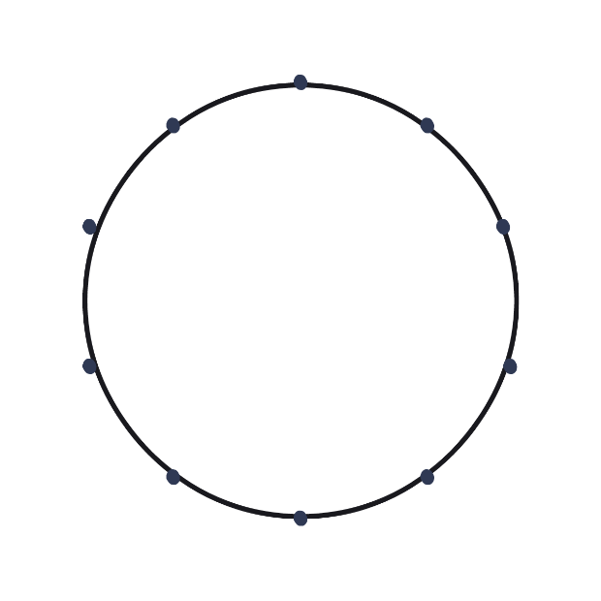

HUNDRETHS

BASE 2 - HALVES

BASE 3 - THIRDS

BASE 4 - QUARTERS

BASE 5 - FIFTHS

BASE 6 - SIXTHS

BASE 2: MULTIPLES –
HALVES QUARTERS SIXTHS

COLOR IN THE RIGHT HALF OF THE CIRCLE.
HOW MANY PIECES ARE COLORED IN EACH?
HALVES ______________
QUARTERS ____________
SIXTHS _________________
BASE 2:
EIGHTHS TENTHS TWELFTHS

COLOR IN THE RIGHT HALF OF THE CIRCLE.
HOW MANY PIECES ARE COLORED IN EACH?
HALVES ______________
QUARTERS ____________
SIXTHS _________________

BASE 3
THIRDS SIXTHS NINTHS

COLOR THE TOP RIGHT THIRD
HOW MANY PIECES ARE COLORED IN EACH
THIRDS
SIXTHS
NINTHS
BASE 3

TWELTHS FIFTEENTHS EIGHTEENTHS
COLOR THE TOP RIGHT THIRD
HOW MANY PIECES ARE COLORED IN EACH
TWELFTHS
FIFTEENTHS
EIGHTEENTHS
BASE 5
FIFTHS TENTHS FIFTEENTHS

COLOR THE TOP RIGHT FIFTH
HOW MANY PIECES ARE COLORED IN EACH
FIFTHS
TENTHS
FIFTEENTHS
PERCENTAGES

